* Introduction to React.js

- React.js is a JavaScript library used for building user interface (UIs) and single-page applications(SPA)

- Created by Jordan Walke at Facebook

- Most popular Javascript library for frontend development.

- React is all about components

* Why React.js?

React is a declarative because as it describes what the UI should look like rather than how to achieve it. This makes the code easier to read and maintain, as it is more focused on the end result rather than the steps involved in getting there.

For example:

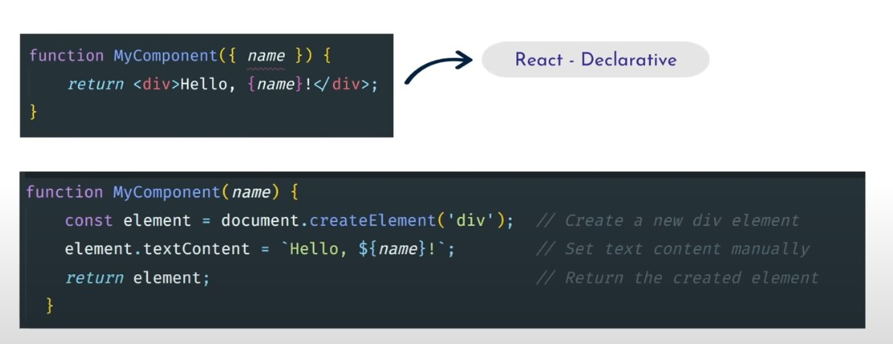The first one is react which is declarative as we don’t use any DOM or many other things to show the text.

The second one is javascript imperative as we have to import the html things and then do the DOM in order to show the text.

* 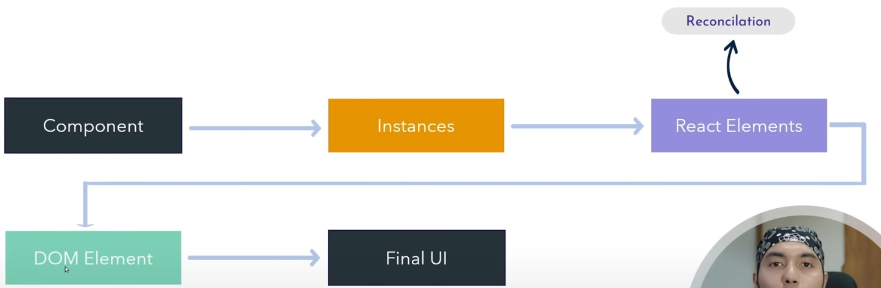How React Works
* Why React over Vanilla Javascript
* Because React has a concept called components which combines all HTML, CSS and Javascript by feature Instead of HTML, CSS and JavaScript completely.
* Why React Js
* ­­­React is the Most Popular Javascript library for building user interfaces.
* Component Based Architecture
* Declarative UI
* Rich ecosystems – npm packages
* Strong Community Support – Online / Github

Table of Content

1. What is JSX (Tut 5)
2. What is Components (Tut 6)
3. Types of Components (Tut 6)
4. What is React Fragment (Tut 7)
5. Dynamic Values (Tut 8)